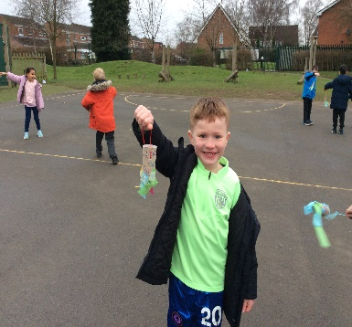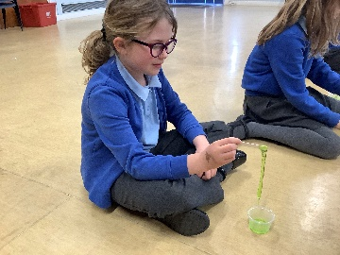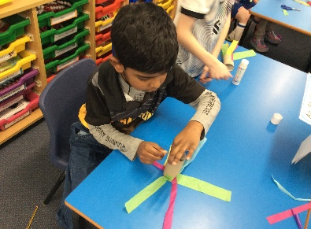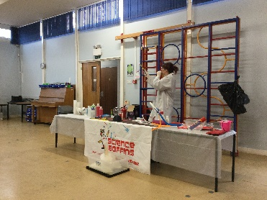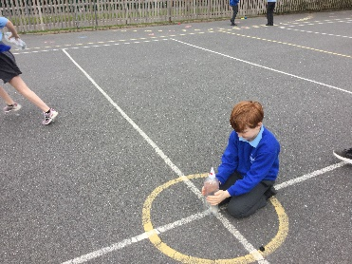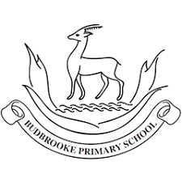

Intent

At Budbrooke Primary School, we hope our children will develop their scientific knowledge and skills through carefully planned, exciting Science opportunities, through embedded and topical science sessions. Most Science lessons are cross-curricular, due to our following of the Cornerstones programme. Links to embed previous learning and deepen understanding are planned in. With each new topic, previous learning is considered and built upon to promote progression across year groups. We aim to support children to develop an understanding of the process and methods of Science by providing a range of Scientific enquiries, investigations and questions to help them explore the world around them. We promote children to develop their own questions and methods when investigating Scientific phenomenon, to develop children’s enquiry skills. We hope to develop and nurture our children’s curiosity by not only following the National Curriculum, but providing additional opportunities to help follow their questions and interests. By providing these opportunities, we hope to develop an enjoyment, and appreciation of the Sciences.

Impact

The impact of our curriculum design will lead to good progress over time. Children should leave school having met the expected -age related expectations for Science. Through the continual access to science, the excitement of science week, and use of the science lab, children should develop a love of science. They will continue to be inspired to be future scientists. This will be measured through pupil discussions, monitoring o work and feedback from Science Week itself.

Implementation

Cornerstones is used as our key resource for teaching across the curriculum. It provides exciting and engaging topic-based lessons for the children to explore science, and covers all of the national curriculum objectives.

At Budbrooke we run a science week each year where Science is the primary focus. Children have the opportunity to attend workshops and demonstrations externally throughout the year. In addition, we run a Science fair where we celebrate children’s scientific creativity with parents and carers.

At Budbrooke we have a science area which children and staff can use for scientific enquiry. We have a wealth of resources to aid with demonstrations and investigations. We enjoy displaying and celebrating children’s work around the school.

Children also have the opportunity to take a leadership role and join the eco-council. The Eco-Councillors help with litter picking, planting flowers and trees, and promote a positive school-wide approach to keeping the school environmentally friendly.

Science